End-Term Project Report on
Emotional Response Robot using Raspberry Pi 4
Submitted by
Arjumand Khan (2341011060)
Aima Aftab (2341001034)
Yasolipsa Bhoi (2341002177)
Sanjana Baral (2341002031)
Amarjeet Ranjan (2341018075)
Ankit Pritam Mallick (2341013084)

B. Tech. (CSE(IOT) 5th Semester (Section–23412O3)



DEPARTMENT OF COMPUTER SCIENCE AND ENGINEERING
Institute of Technical Education and Research

SIKSHA ‘O’ ANUSANDHAN
DEEMED TO BE UNIVERSITY

Bhubaneswar, Odisha, India.
(December 2025)

Abstract

- In recent years, the integration of Internet of Things (IoT) with artificial intelligence has enabled smart and interactive systems. This project focuses on designing and developing an emotion detection based interactive robot using Raspberry Pi.
- The system captures human facial expressions through a camera module, processes the image using a trained machine learning model, and classifies emotions such as happy, sad, angry, or neutral.
- Based on the detected emotion, the robot responds through movements .
- The project demonstrates real-time emotion recognition, IoT integration, and human-robot interaction, making it useful for applications in healthcare, education, and customer service.

Contents

Abstract i
Contents ii
Chapter 01: Introduction 1
1.1. Introduction 1
1.2. Background 1
1.3. Project Objectives 1
1.4. Scope 1
1.5. Project Management 1
1.6. Overview and Benefits 2
1.7. Organization of the Report 2
Chapter 02: Background Review & Survey 3
2.1. Related Works 3
Chapter 03: Theoretical Aspects 4
3.1. Project Aspects 4
3.1.1. Features of IoT 4
3.1.2. Advantages of IoT 4
3.1.3. Disadvantages of IoT 4
3.1.4. Application areas of IoT 4
3.2. IOT Technologies and Protocols // related to project 4
3.3. Project Layout 5
3.3.1. Brief Description 5
3.4. Background Theory 5
Chapter 04: Hardware Requirements 6
4.1. Raspberry Pi 4 / Raspberry Pi 5 6
4.1.1. Features 6
4.1.2. Pin Configuration 6
4.2. Camera 6
4.3. Sensors 6
4.3.1. …………………………………………………………………………………6
4.4. Motor Drivers 6
4.5. Motors 6
4.6. Working of the proposed system 6
4.6.1. Block Diagram of the system 6
4.6.2. Circuit Diagram 6
4.6.3. Working 6
4.6.4. Components Required 7
Chapter 05: Software Requirements 8
5.1. Thonny IDE/ VS code/ Python 8
5.2. Logic and Flowchart 8
Chapter 06: Project development & Testing Aspects 9
6.1. Hardware Integration 9
6.2. Software Set-up 9
6.3. Testing 9
6.4. Results and Discussions 9
Chapter 07: Conclusion & Future Scope 10
7.1. Conclusion 10
7.2. Limitations 10
7.3. Further Enhancement and Future Scope 10
References 11
Appendix 01 12
A01.1. Code Listing 12
A01.2. Main Code 12
A01.3. Libraries 12
Appendix 02 13
A02.1. Project Proposal Form 13
A02.2. Project Management 13
A02.3. Bill of Material 13
Appendix 03 15
A03.1. Data Sheets 15

Chapter 01: Introduction

Introduction

Emotion recognition plays a vital role in human interaction. By combining IoT devices with AI techniques, machines can understand and respond to human emotions. This project implements an IoT-enabled robotic system that detects facial emotions and reacts accordingly.

Background

With advancements in embedded systems and machine learning, low-cost platforms like Raspberry Pi are widely used for intelligent applications. Facial expression recognition using cameras and neural networks has gained popularity in robotics and automation fields

Project Objectives
- To detect human facial emotions using a camera
- To process emotion data using a trained ML model
- To design an interactive robot that responds to emotions
- To implement IoT concepts using Raspberry Pi

Scope

The project is limited to basic emotion detection using facial expressions. It does not include voice-based emotion analysis or cloud storage.

Project Management

The project was carried out in phases including planning, background study, system design, implementation, testing, and documentation.
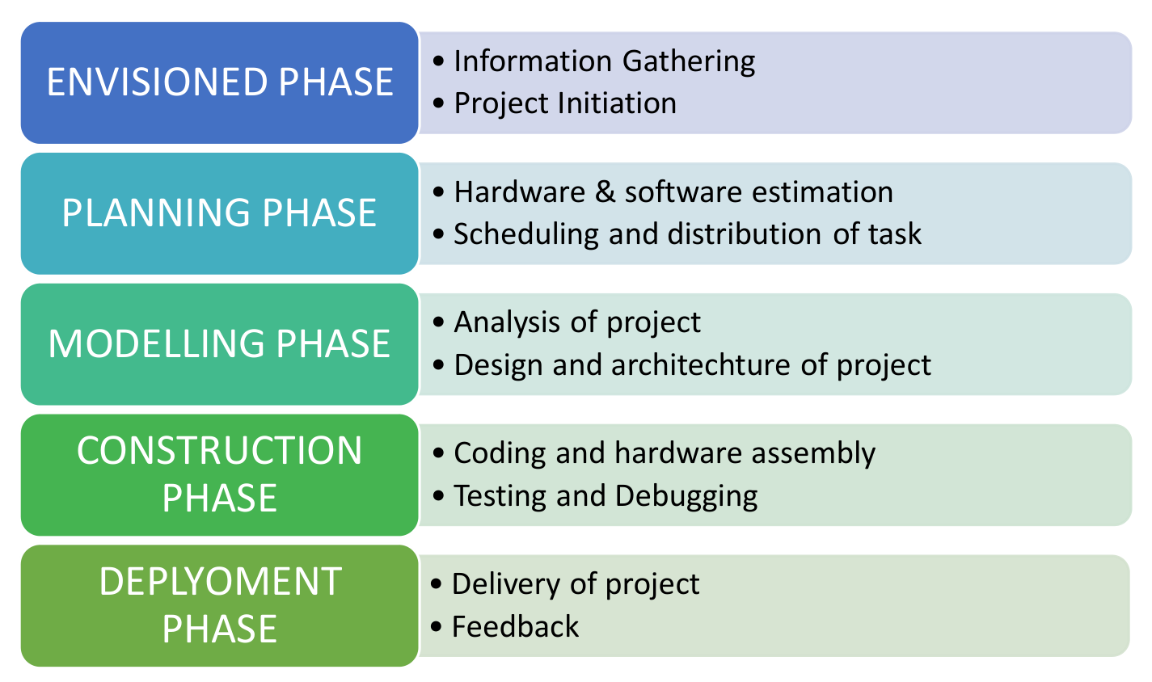
Figure 1.1. Model of phases in project management.

Overview and Benefits
- Enhances human–computer interaction
- Low-cost implementation
- Real-time emotion recognition
- Educational and research-oriented application

Organization of the Report

The report is organised into the following chapters. Each chapter is unique on its own and is described with necessary theory to comprehend it.
Chapter 2 covers background survey, Chapter 3 discusses theoretical aspects, Chapter 4 explains hardware, Chapter 5 software, Chapter 6 development and testing, and Chapter 7 concludes the report.

Chapter 02: Background Review & Survey

Related Works
Emotion recognition using facial expressions has been an active area of research in the field of computer vision and artificial intelligence. Facial expressions are considered one of the most natural and effective ways to understand human emotions, making them suitable for human–computer interaction systems.
Several researchers have proposed facial expression recognition systems using machine learning techniques. Traditional approaches relied on handcrafted feature extraction methods such as Local Binary Patterns (LBP), Histogram of Oriented Gradients (HOG), and Support Vector Machines (SVM). These methods provided reasonable accuracy but required careful feature engineering and were sensitive to lighting conditions and facial orientation.
Raspberry Pi has been widely adopted as a platform for implementing embedded computer vision applications due to its low cost, compact size, and support for camera modules. Researchers have implemented real-time face detection and recognition systems on Raspberry Pi using OpenCV and Python. Although Raspberry Pi has limited computational power compared to high-end systems, optimized models allow acceptable real-time performance.
The existing literature highlights that vision-based emotion recognition using Raspberry Pi is feasible and effective for academic and prototype-level projects. These studies form the foundation for the proposed system, which focuses on real-time facial emotion detection using a simple and cost-effective embedded platform.

Chapter 03: Theoretical Aspects

Project Aspects

The proposed project integrates concepts from Internet of Things (IoT), computer vision, and artificial intelligence. The system uses a camera to sense human facial expressions, processes the data using Raspberry Pi, and displays the detected emotion, enabling intelligent human–machine interaction.

Features of IoT

- Intelligence
- Connectivity
- Dynamic Nature
- Enormous Scale
- Sensing
- Heterogeneity
- Security

Advantages of IoT

- Communication
- Automation and Control
- Information
- Monitoring
- Efficiency

Disadvantages of IoT

- Compatibility
- Complexity
- Privacy/Security
- Safety

Application areas of IoT
- Smart homes
- Healthcare
- Robotics
- Education

IOT Technologies and Protocols (Related)

- Bluetooth: Used for short-range wireless communication between devices with low power consumption.
- Zigbee: Used for short-range wireless communication between devices with low power consumption.
- Z-Wave: Used mainly in home automation for reliable and secure low-power device communication
- Wi-Fi: Provides high-speed internet connectivity and is used in this project to connect Raspberry Pi to the network..
- Cellular: Uses mobile networks (4G/5G) to provide long-range connectivity when Wi-Fi is unavailable.
- NFC: A very short-range communication technology used for identification and authentication.
- LoRaWAN: A long-range, low-power protocol used for transmitting IoT data over large distances.

Project Layout

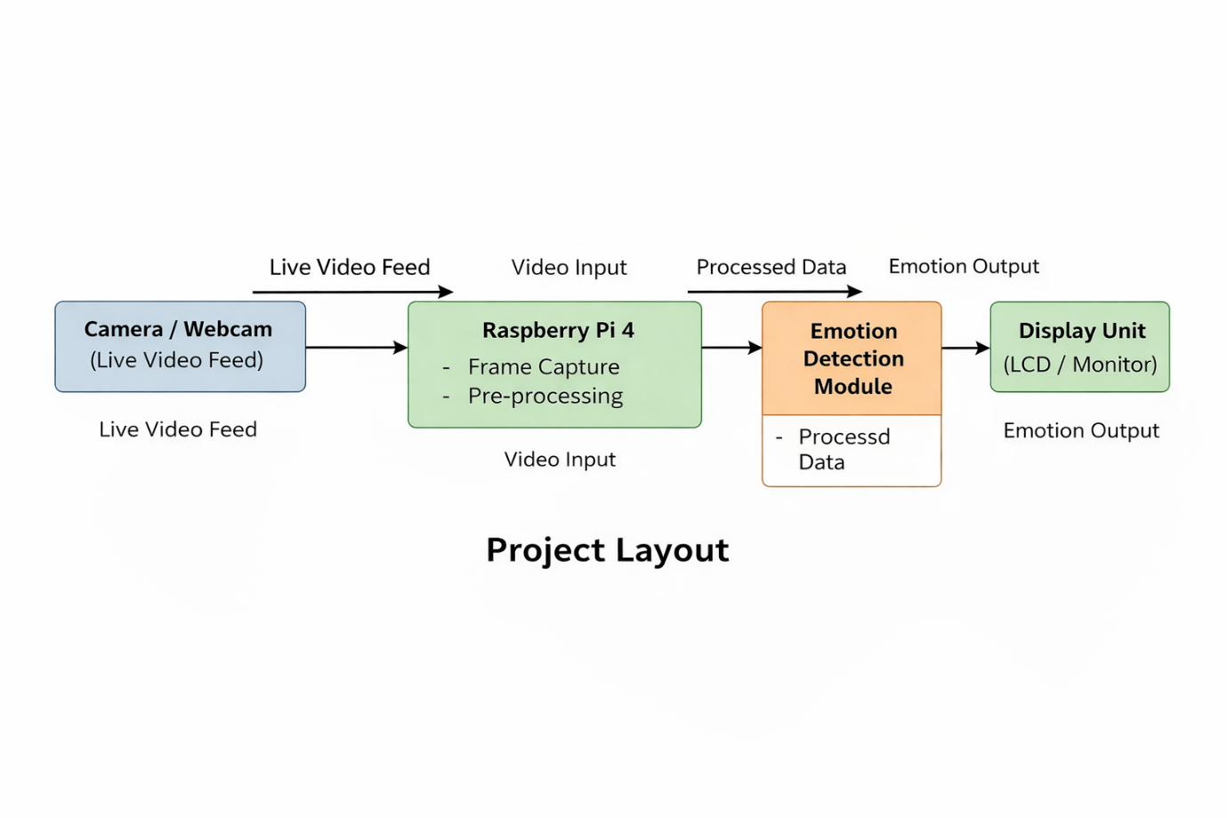
Figure 3.1. Layout of project module

Brief Description

The camera captures live video of a human face and sends it to the Raspberry Pi. The Raspberry Pi preprocesses the video frames and applies face detection algorithms. The detected facial features are then passed to a convolutional neural network that classifies the emotion. Finally, the detected emotion is displayed on a monitor or LCD screen.

Background Theory
Facial emotion recognition is based on analyzing facial features such as eyes, eyebrows, mouth, and facial contours. Computer vision techniques are used to detect faces from video frames. Once a face is detected, it is resized and normalized before being passed to a neural network model.
A Convolutional Neural Network (CNN) is commonly used for emotion classification as it automatically extracts spatial features from images. The CNN processes the facial image through multiple layers to identify patterns associated with different emotions and outputs the most probable emotion class.

Chapter 04: Hardware Requirements

Raspberry Pi 4

Raspberry Pi 4 is used as the main processing unit of the system. It handles image acquisition, face detection, emotion classification, and display of results.

Features
- Quad-core ARM Cortex-A72 processor
- Supports USB camera and display output
- GPIO pins for peripheral interfacing
- Supports Python, OpenCV, and TensorFlow

Pin Configuration
- USB ports used for webcam
- HDMI port used for monitor display
- Power input via USB-C

Camera

A USB webcam is used to capture real-time facial images. These images are sent to the Raspberry Pi for further processing.

Sensors

Not Used
No additional sensors are used in this project as emotion detection is purely vision-based.

Motor Drivers
Not Used
Motor drivers are not required since the project does not involve motion control.

Motors
Not Used
No motors are used as the system focuses only on emotion detection and display.

Working of the proposed system

Block Diagram of the system

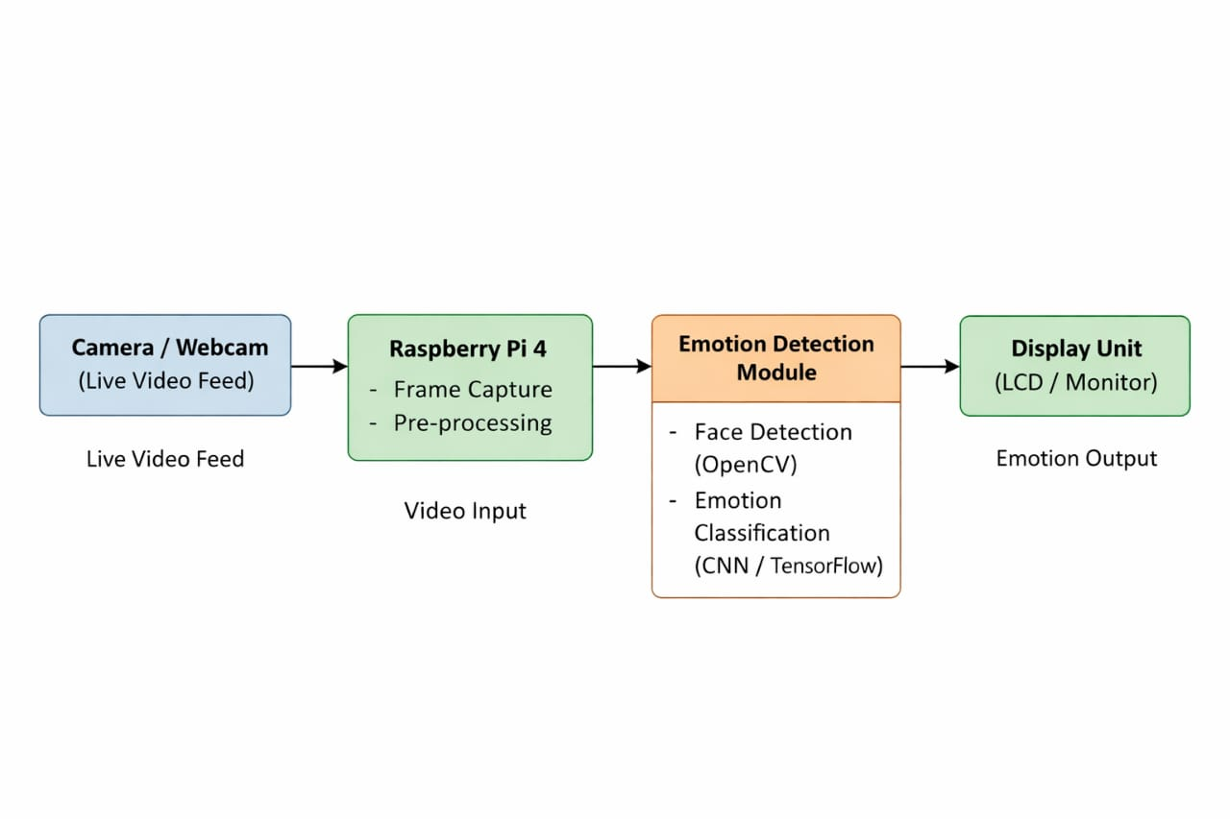

Circuit Diagram

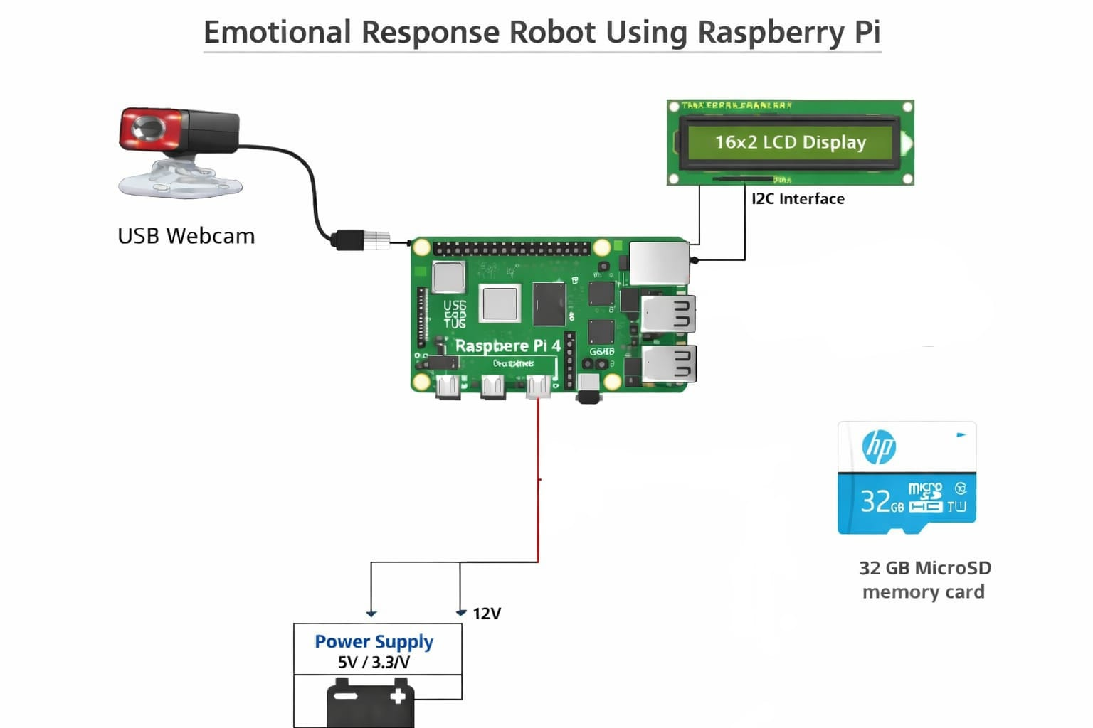

Working
- The webcam captures live facial images.
- Raspberry Pi receives video frames and preprocesses them.
- Face detection is performed using OpenCV.
- Detected faces are passed to a CNN-based emotion classification model.
- The identified emotion is displayed on the screen.

Components Required
Table 4.1. Component listing.
Sl. No. | Component and Specification | Quantity
 | Raspberry Pi 4 (4GB RAM) | 1
 | USB Webcam | 1
 | 16×2 LCD Display / Monitor | 1
 | MicroSD Card (32 GB) | 1
 | Breadboard | 1
 | Connecting Wires | As reqd.
 | Power Supply | 1

Chapter 05: Software Requirements

Thonny IDE/ VS code/ Python
Python is used as the programming language for developing the emotion detection system on the Raspberry Pi platform. It supports computer vision and machine learning libraries required for face detection and emotion classification. Thonny IDE or Visual Studio Code is used for writing, editing, and executing the Python programs efficiently.

Logic and Flowchart

The system follows a sequential logic starting from video acquisition to emotion display. Initially, the webcam captures live video frames which are passed to the Raspberry Pi. Each frame is processed to detect human faces using computer vision techniques. The detected face region is then analyzed by a trained neural network model to classify the emotion. Finally, the detected emotion is displayed on the monitor in real time.
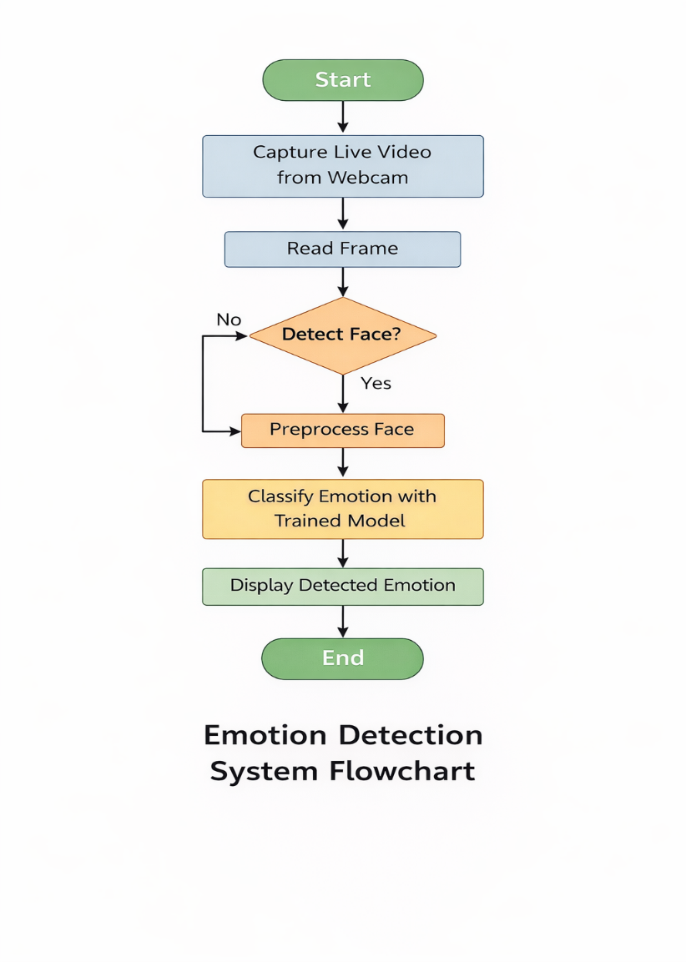

Chapter 06: Project development & Testing Aspects

Hardware Integration

The hardware components of the system were integrated by connecting the webcam and display unit to the Raspberry Pi. The webcam was connected through the USB interface to capture real-time facial images. The display unit was connected using an HDMI cable to show the output. The Raspberry Pi was powered using a regulated power supply. Proper connections were ensured to avoid power or data transmission issues during operation.
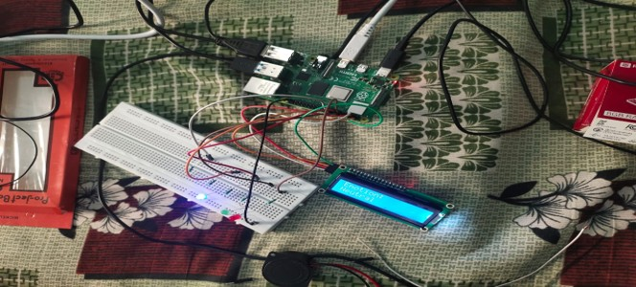

Software Set-up

The software environment was set up on the Raspberry Pi by installing the required operating system and necessary Python libraries. Libraries such as OpenCV were installed for face detection and image processing, while TensorFlow and Keras were used for emotion classification. The Python program was executed using Thonny IDE or Visual Studio Code. The system was configured to access the webcam and display the detected emotion in real time.

Testing
Testing was carried out to verify the correct functioning of the system. The webcam was tested for proper video capture, and the face detection algorithm was evaluated under different lighting conditions. Various facial expressions were presented in front of the camera to test the emotion classification model. The system performance was observed to ensure stable and continuous operation.

Results and Discussions

The system successfully detected human faces and classified emotions in real time. The detected emotions were displayed correctly on the screen. The results demonstrate that the proposed system works efficiently on the Raspberry Pi platform. Minor variations in accuracy were observed due to lighting and facial orientation, but overall performance was satisfactory for a prototype-level implementation.

Chapter 07: Conclusion & Future Scope

Conclusion

The emotion detection system using Raspberry Pi 4 was successfully designed and implemented. The system is capable of capturing real-time facial images, detecting human faces, and classifying emotions using computer vision and machine learning techniques. The detected emotion is displayed on the screen, demonstrating effective human–computer interaction. This project highlights the practical application of affective computing using a low-cost embedded platform.

Limitations

The system has certain limitations. The accuracy of emotion detection depends on lighting conditions and facial orientation. The system can recognize only a limited set of emotions and may not perform accurately for subtle or mixed expressions. Additionally, the processing capability of Raspberry Pi restricts the use of very complex deep learning models.

Further Enhancement and Future Scope

The system can be further enhanced by improving the accuracy of emotion classification using advanced deep learning models. Additional modalities such as speech-based emotion recognition can be integrated. The system can also be extended to store emotion data or connect to cloud platforms for large-scale analysis. Such enhancements can make the system more robust and suitable for real-world applications.

References

- C. Shan, S. G. Gong, and P. W. McOwan, “Facial Expression Recognition Based on Local Binary Patterns,” Image and Vision Computing, vol. 27, no. 6, pp. 803–816, 2009.
- OpenCV Documentation, “Open Source Computer Vision Library.”
Available: https://opencv.org/ (Accessed: Dec. 2025)
- TensorFlow Documentation, “Machine Learning Framework.”
Available: https://www.tensorflow.org/ (Accessed: Dec. 2025)
- Raspberry Pi Foundation, “Raspberry Pi Documentation.”
Available: https://www.raspberrypi.org/ (Accessed: Dec. 2025)
- I. Goodfellow, Y. Bengio, and A. Courville, Deep Learning. MIT Press, 2016.

Appendix 01

A01.1. Code Listing

The following user-defined functions are used in the project:
- capture_frame() – Captures video frames from the webcam.
- detect_face() – Detects human faces from the input frame using computer vision techniques.
- preprocess_image() – Converts the detected face into a suitable format for emotion classification.
- predict_emotion() – Classifies the emotion using a trained neural network model.
- display_output() – Displays the detected emotion on the screen.

A01.2. Main Code

The main program initializes the webcam, loads the emotion detection model, and continuously processes video frames. Each frame is analyzed for face detection and emotion classification. The detected emotion is displayed in real time until the program is terminated.
CODE:
import cv2
import numpy as np
from tensorflow.keras.models import load_model

# Load pre-trained emotion detection model
emotion_model = load_model("emotion_model.h5")

# Emotion labels (example)
emotion_labels = ['Angry', 'Disgust', 'Fear', 'Happy', 'Neutral', 'Sad', 'Surprise']

# Load Haar Cascade for face detection
face_cascade = cv2.CascadeClassifier(
cv2.data.haarcascades + 'haarcascade_frontalface_default.xml'
)

# Initialize webcam
cap = cv2.VideoCapture(0)

while True:
ret, frame = cap.read()
if not ret:
break

gray = cv2.cvtColor(frame, cv2.COLOR_BGR2GRAY)

# Detect faces
faces = face_cascade.detectMultiScale(
gray,
scaleFactor=1.3,
minNeighbors=5
)

for (x, y, w, h) in faces:
face = gray[y:y+h, x:x+w]
face = cv2.resize(face, (48, 48))
face = face / 255.0
face = np.reshape(face, (1, 48, 48, 1))

# Predict emotion
prediction = emotion_model.predict(face)
emotion_index = np.argmax(prediction)
emotion = emotion_labels[emotion_index]

# Draw rectangle and emotion text
cv2.rectangle(frame, (x, y), (x+w, y+h), (0, 255, 0), 2)
cv2.putText(
frame,
emotion,
(x, y - 10),
cv2.FONT_HERSHEY_SIMPLEX,
0.9,
(0, 255, 0),
2
)

cv2.imshow("Emotion Detection System", frame)

# Press 'q' to exit
if cv2.waitKey(1) & 0xFF == ord('q'):
break

cap.release()
cv2.destroyAllWindows()

A01.3. Libraries
The following libraries are used in the project:
- OpenCV
- NumPy
- TensorFlow
- Keras

Appendix 02

A02.1. Project Proposal Form

The project proposal form was prepared and duly signed from our Faculty-in-Charge Dr. Shaktijeet Mahapatra and Dr. Bhanja Kishor Swain. The same is attached at the last of this report.

A02.2. Project Management

# | Component | Individual Contributions in % |  |  |  |  |  | Total
 |  | Arjumand Khan | Aima Aftab | Sanjana Baral | Yasolipsa Bhoi | Amarjeet Ranjan | Ankit Pritam Mallick
 | Planning | 20% | 16% | 16% | 16% | 17% | 15% | 100%
 | Background Research and Analysis | 18% | 17% | 16% | 17% | 16% | 16% | 100%
 | Hardware design | 19% | 15% | 18% | 15% | 18% | 15% | 100%
 | Software design | 20% | 15% | 15% | 17% | 18% | 15% | 100%
 | Testing | 17% | 17% | 16% | 16% | 17% | 17% | 100%
 | Final Assembling | 18% | 17% | 16% | 17% | 16% | 16% | 100%
 | Project report writing | 15% | 20% | 18% | 18% | 15% | 14% | 100%
 | Presentation | 17% | 17% | 17% | 17% | 16% | 16% | 100%
 | Logistics | 16% | 16% | 16% | 16% | 16% | 20% | 100%

A02.3. Bill of Material

Table 1. Component listing.
# | Component | Specification | Unit Cost | Quantity | Total
 | Raspberry Pi 4 | Quad-core ARM Cortex-A72, 4GB RAM | 8300 | 1 | 8300
 | USB Webcam | USB 2.0, 720p / 1080p | 2995 | 1 | 2995
 | 16×2 LCD Display | Alphanumeric LCD, 5V | 152 | 1 | 152
 | MicroSD Card | 32 GB | 879 | 1 | 879
 | Breadboard | Standard | 158 | 1 | 158
 | Connecting Wires | Jumper wires | 1 | As reqd. | 198
 | Power Adapter | 5V, 3A | 598 | 1 | 598
Grand Total |  |  |  |  | 13,280

Appendix 03

A03.1. Data Sheets

Raspberry Pi 4

Operating Voltage: 5V DC

Recommended Current: 3A

Processor: Quad-core ARM Cortex-A72

USB Ports: USB 2.0 and USB 3.0

HDMI Output: Dual micro-HDMI

Operating System: Raspberry Pi OS

USB Webcam

Operating Voltage: 5V DC (USB powered)

Interface: USB 2.0

Resolution: 720p / 1080p (depending on model)

Frame Rate: 30 fps

16×2 LCD Display

Operating Voltage: 5V DC

Display Type: Alphanumeric LCD

Interface: Parallel (HD44780 compatible)

Backlight Voltage: 5V DC

MicroSD Card

Storage Capacity: 32 GB

Operating Voltage: 3.3V

Usage: Operating system and program storage

Power Supply

Input Voltage: 220–240V AC

Output Voltage: 5V DC

Output Current: 3A

Connecting Wires

Type: Jumper / USB / HDMI cables

Operating Voltage: As per connected device

Usage: Power and data transmission

